Landing, Login, and Enrollment Pages Development

Jada Alexander

CST 499: Capstone for Computer Software Technology

Professor Charmelia Butler

June 27, 2023

Landing, Login, and Enrollment Pages Development

XAMPP, an acronym for "Cross-Platform (X), Apache (A), MySQL (M), PHP (P), and Perl (P)," is a powerful open-source software package that serves as a complete web development solution (“Xampp tutorial – javatpoint”, n.d.). It provides developers with a local server environment to design and test websites or web applications before deploying them to a live server. In the context of developing an online course enrollment system for a college, leveraging XAMPP can greatly facilitate the creation of essential components such as the landing, login, and registration pages. This paper focuses on the development process of these pages, utilizing XAMPP to ensure a seamless user experience and efficient management of the enrollment system. By harnessing the capabilities of XAMPP, educational institutions can streamline their enrollment procedures and provide students with a user-friendly interface to access and register for courses. This paper explores the key steps involved in developing the landing, login, and registration pages using XAMPP, ultimately aiming to enhance the online course enrollment experience for students.

To run a PHP file in XAMPP, follow these simple steps. Firstly, make sure you have installed XAMPP on your system. Start the XAMPP control panel and ensure the Apache server is running as well as MySQL Database. Place your PHP file in the "htdocs" directory located within the XAMPP installation folder. Open your web browser and enter "localhost" in the address bar. Navigate to the specific PHP file by appending its path after the localhost address (e.g., localhost/myfile.php). Press Enter, and the PHP file will be executed by the server, displaying the output or running the desired functionality on your web browser (“Xampp tutorial: How to use XAMPP to run your own web server - udemy blog”, n.d.). See below screenshots: 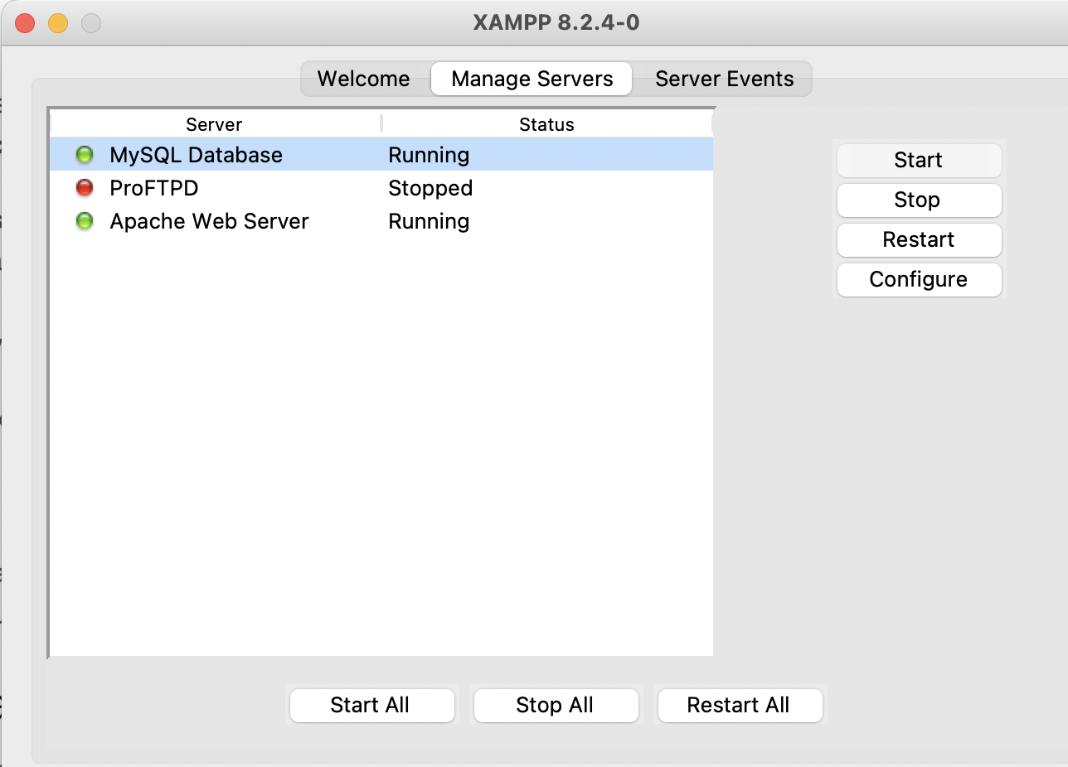

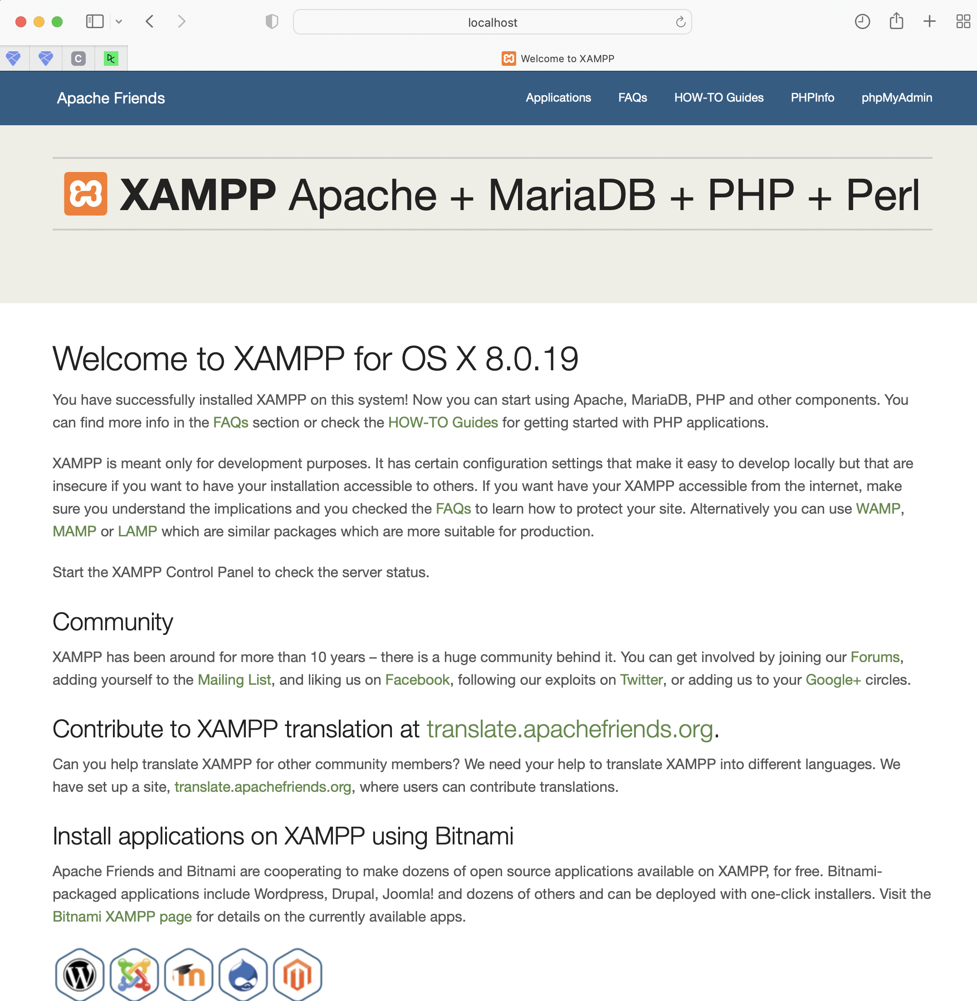

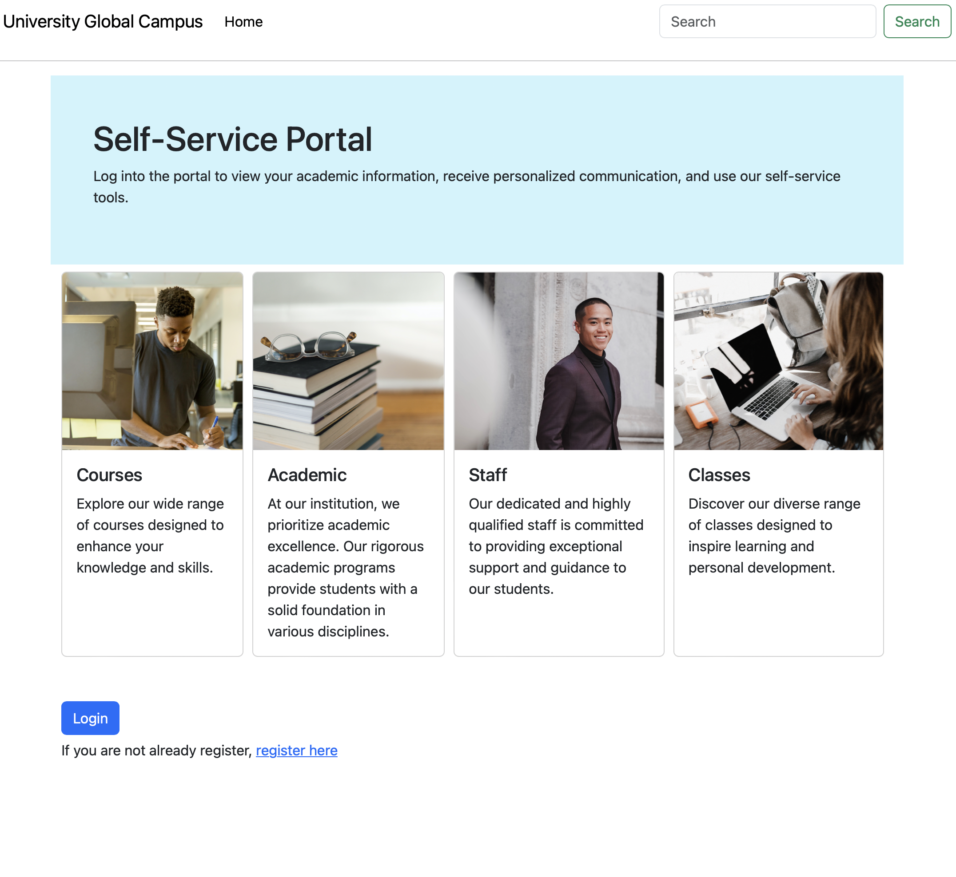

In the development of the online course enrollment system, MySQL database functions were utilized to create, manage, and interact with the database. Here are some of the MySQL functions that were employed:

1. CREATE TABLE: This function was used to create the necessary tables within the database. In this case, the tables "course," "users," and "registrations" were created. Each table was defined with specific columns to store relevant information.

2. INSERT INTO: This function was used to insert data into the tables. For example, when a user registers, their information such as first name, last name, email, address, username, password, phone number, and date of birth were inserted into the "users" table. Additional fields like state and zip code can be added using ALTER TABLE to modify the table structure.

3. SELECT: The SELECT function was used to retrieve data from the tables. For instance, when a student enrolls in a course, a SELECT query is performed to check if the student is already registered and eligible for enrollment.

4. UPDATE: The UPDATE function was used to modify existing records in the database. For example, if a student updates their contact information, an UPDATE query is executed to modify the corresponding fields in the "users" table.

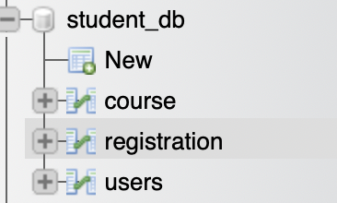

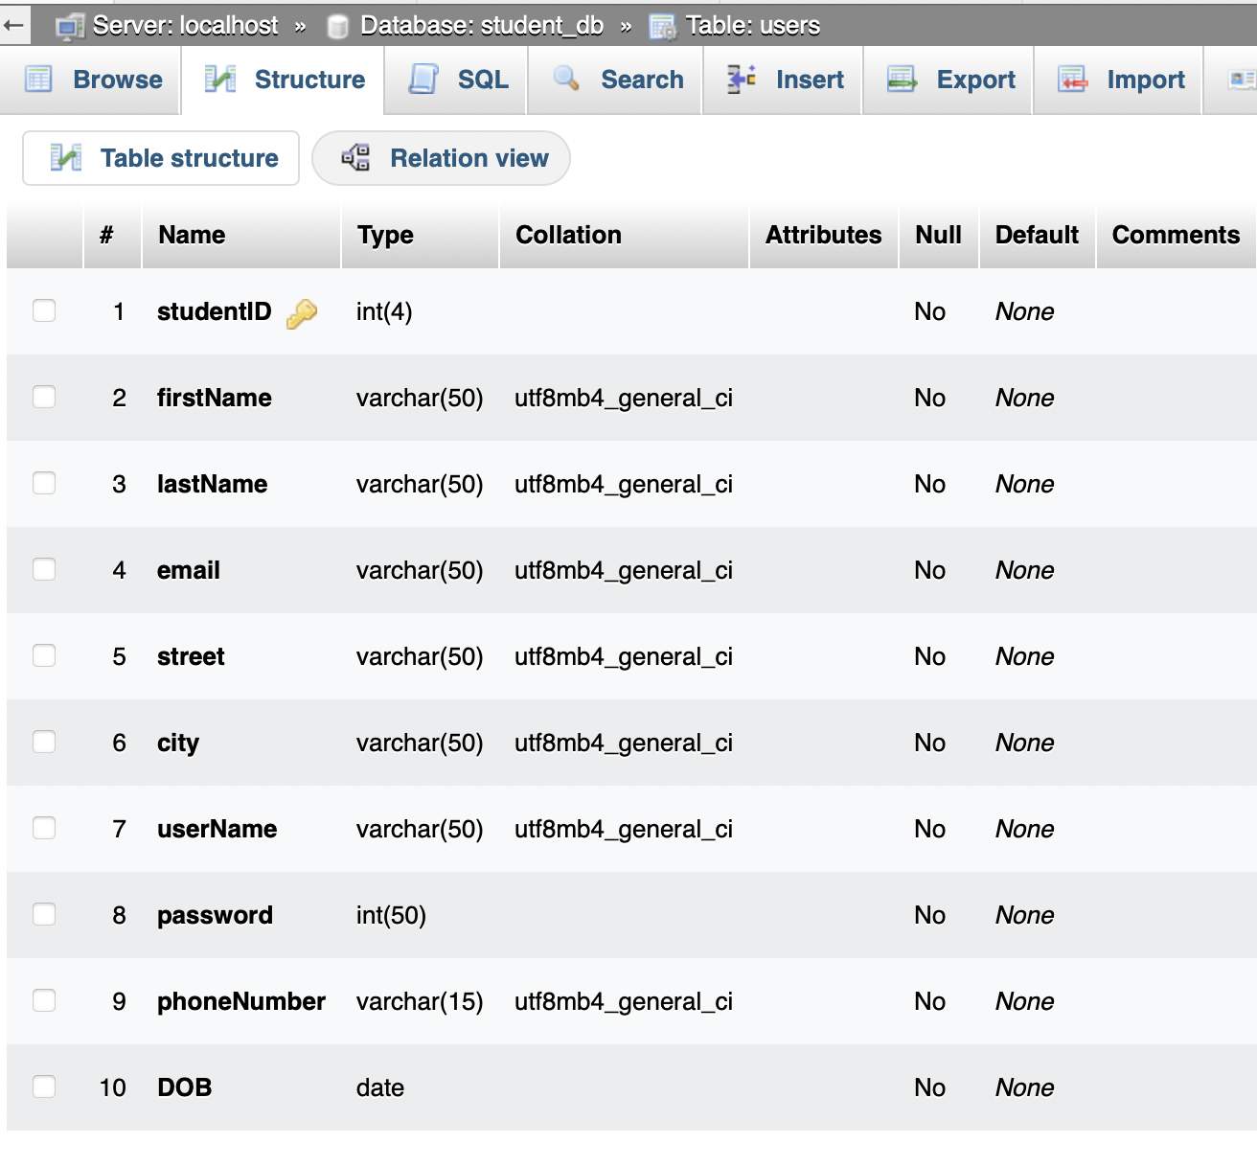

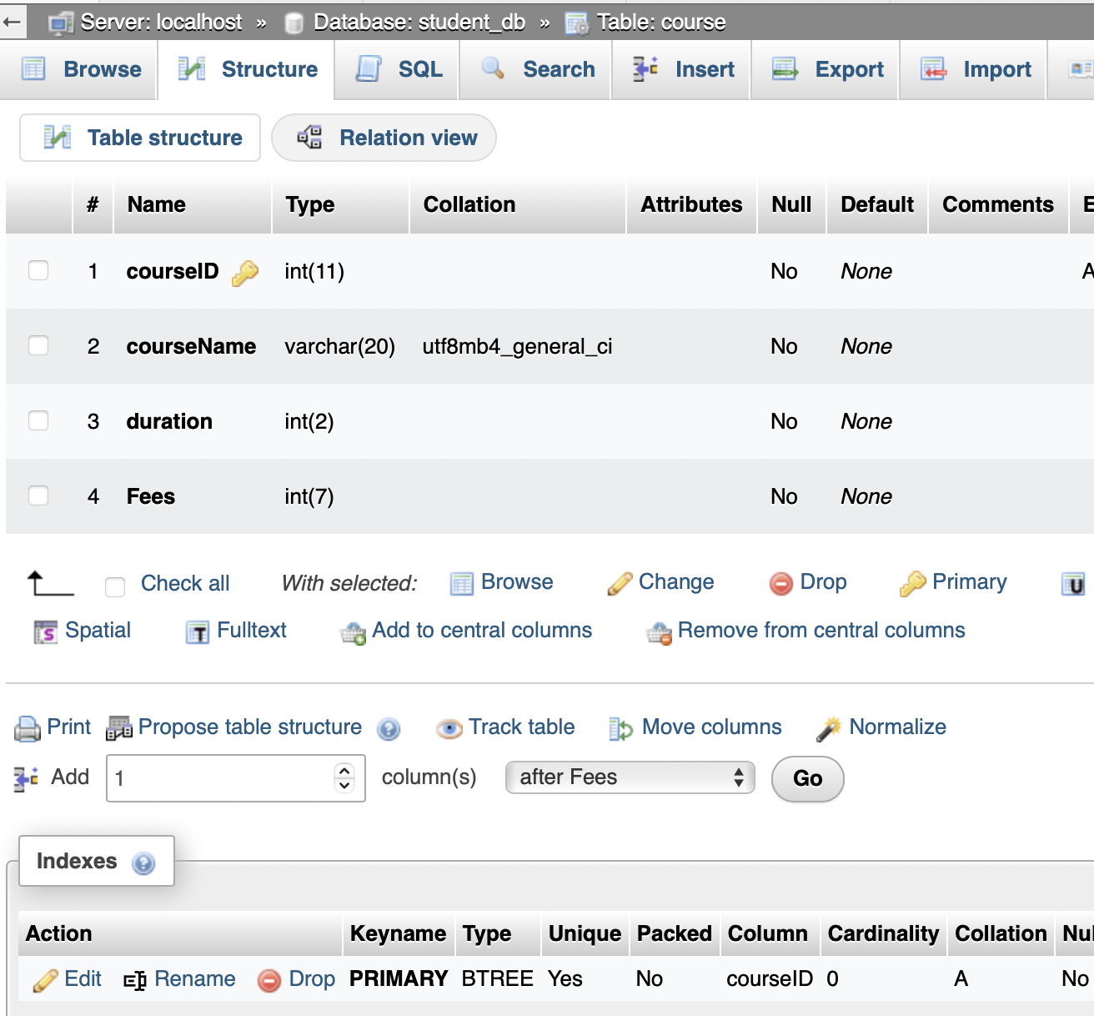

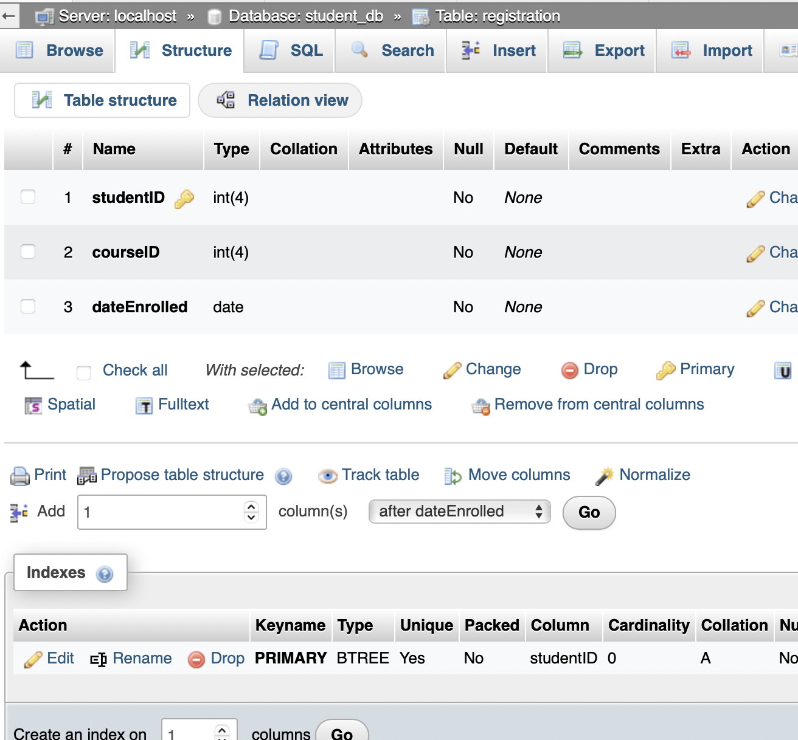

The registration page creation and saving user information in the database involved the following steps. Firstly, an HTML form was designed to collect user details such as first name, last name, email, address, username, password, phone number, and date of birth. Upon form submission, a PHP script was executed to handle the data. The script established a connection to the MySQL database using a custom database connection class. It then sanitized and validated the user input, ensuring data integrity. The validated user information was then inserted into the "users" table using an INSERT INTO query, storing it securely in the database for future reference and login authentication.

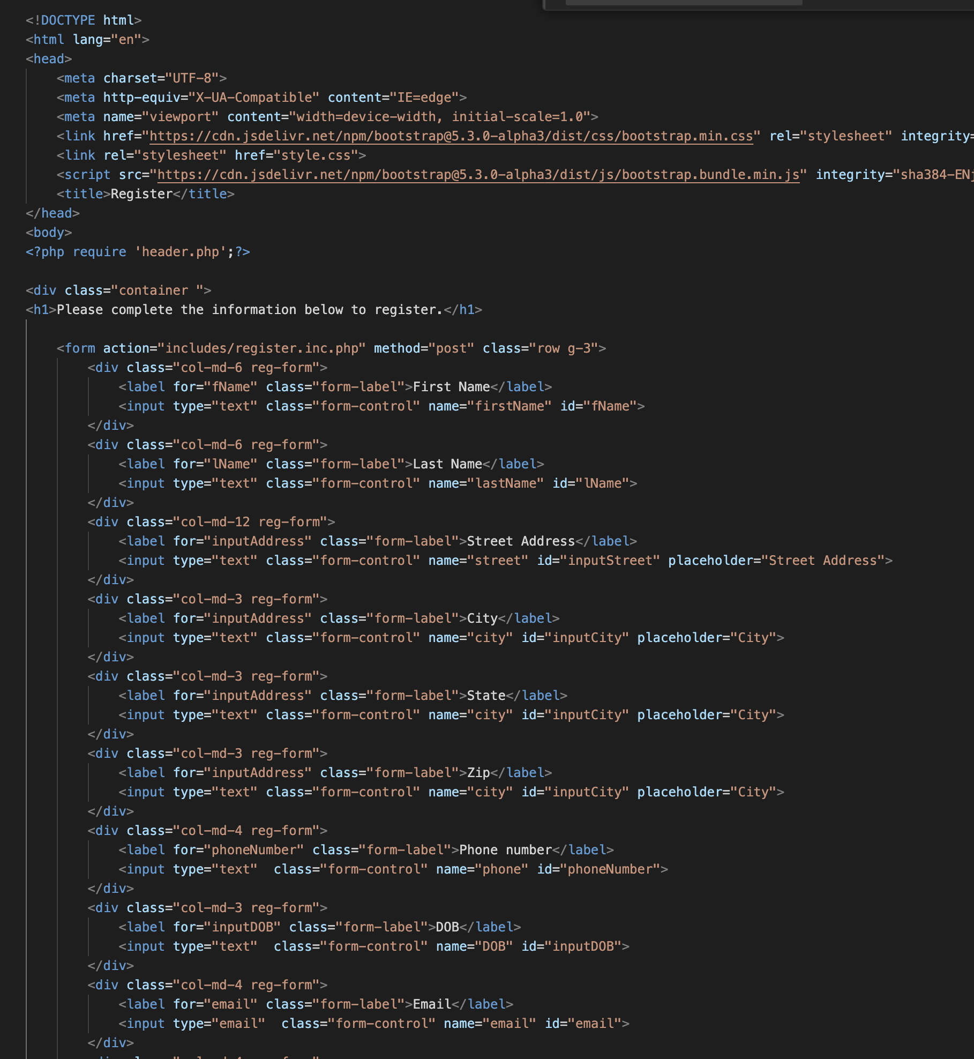

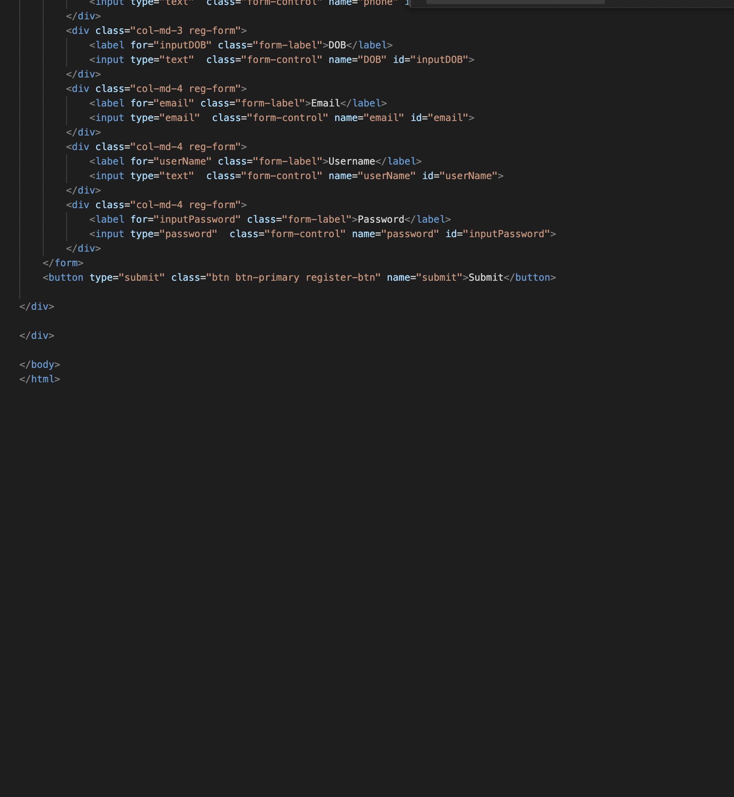

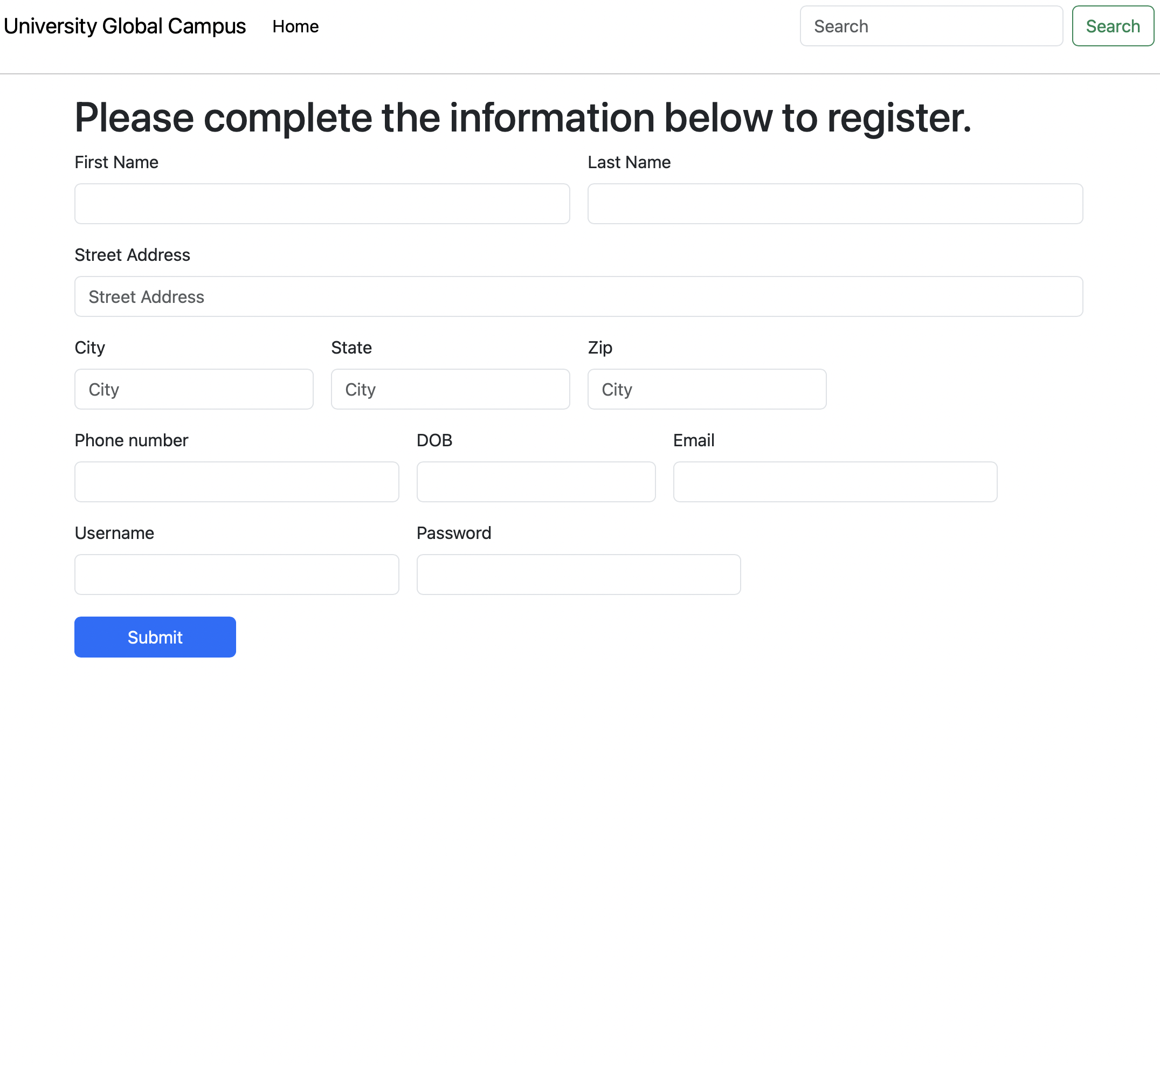

Developing an online course enrollment system requires meticulous planning, attention to detail, and the utilization of appropriate tools and technologies. Throughout this paper, we have delved into the development process of the landing, login, and registration pages for such a system, utilizing the powerful capabilities of XAMPP. By leveraging XAMPP, colleges can create a comprehensive local server environment that facilitates the seamless testing and deployment of these critical components. Together, these components form a cohesive user experience that simplifies the process of selecting and registering for courses.

References

*Xampp tutorial - javatpoint*. www.javatpoint.com. (n.d.). <https://www.javatpoint.com/xampp>

Xampp tutorial: How to use XAMPP to run your own web server - udemy blog. (n.d.-c). https://blog.udemy.com/xampp-tutorial/